**Creating Multi-Form Applications**

When creating multi-form applications, there are two issues to be considered.

1. We have to “construct” the form
2. We have to get data from one form to another.

To construct a new form we need to call the constructor. Assume we have a form in our project called frmOptions. Note: when you create a new windows form application, the default form in named Form1.

frmOptions options = new frmOptions();

This creates a frmOptions class object called options

Once the form is constructed, we need to show it.

options.ShowDialog();

The second issue is how get data transferred from one form to another. Here is one technique:

1. Create a global public static variable in the form to receive the data.
2. Transfer the data from the variable to a control (e.g. a label) on the form.

Here is an example on how to do that.

1. Create a new Windows Form Application project. Call it MultiForm
2. Add a new form to the project and name it frmSecond. Rename Form1.cs to frmMain.cs

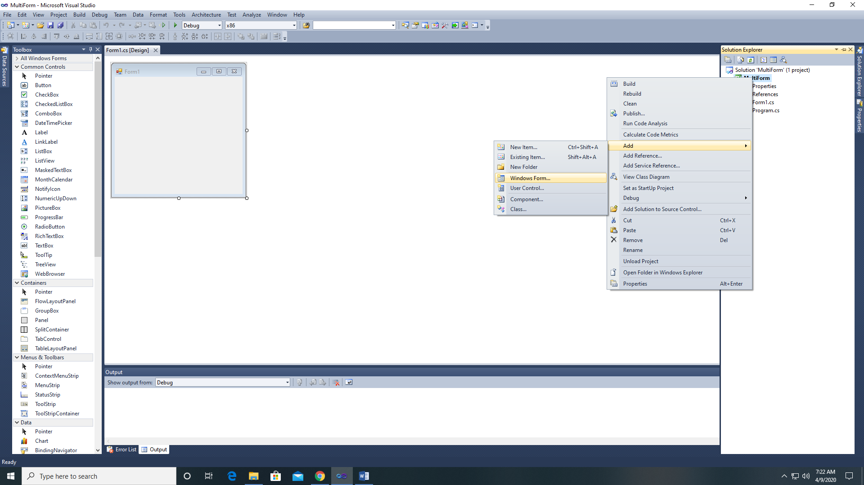 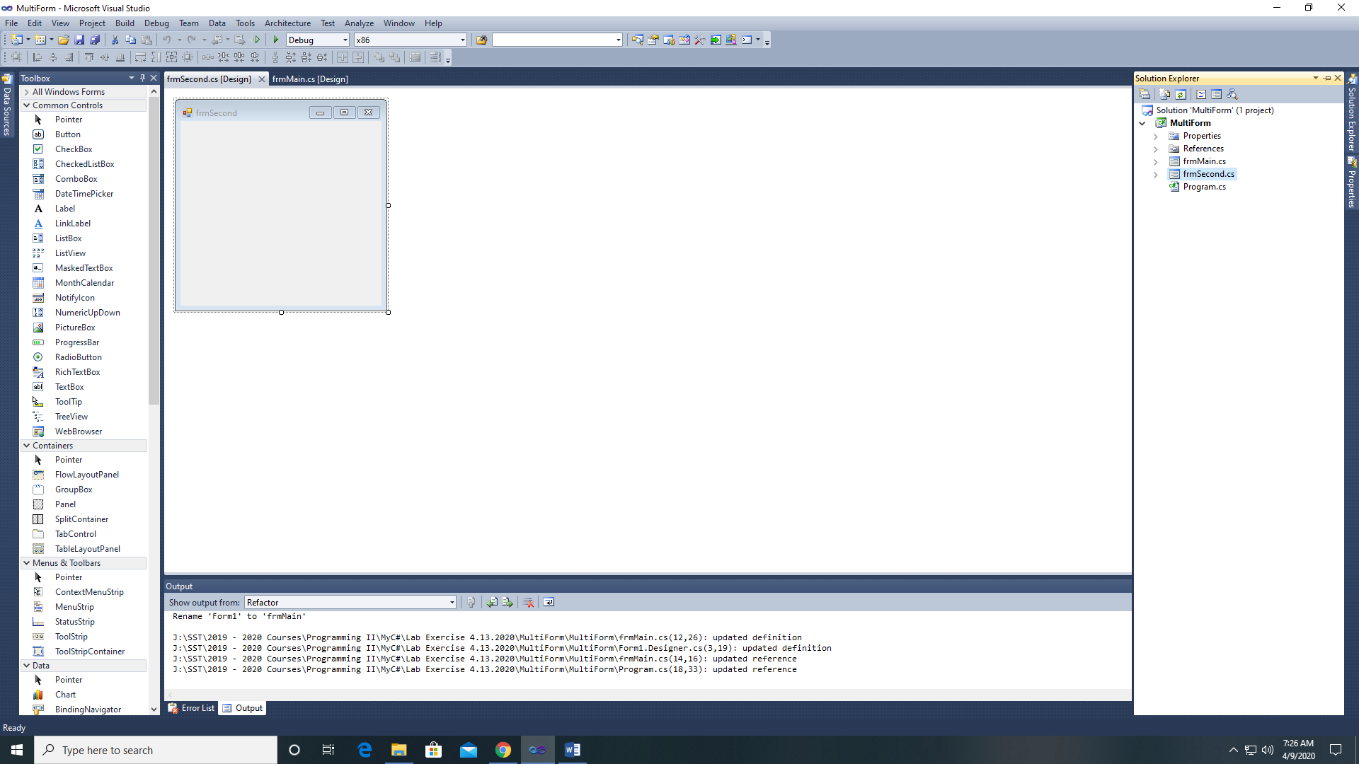

1. Add controls to frmMain (4 labels and a button).

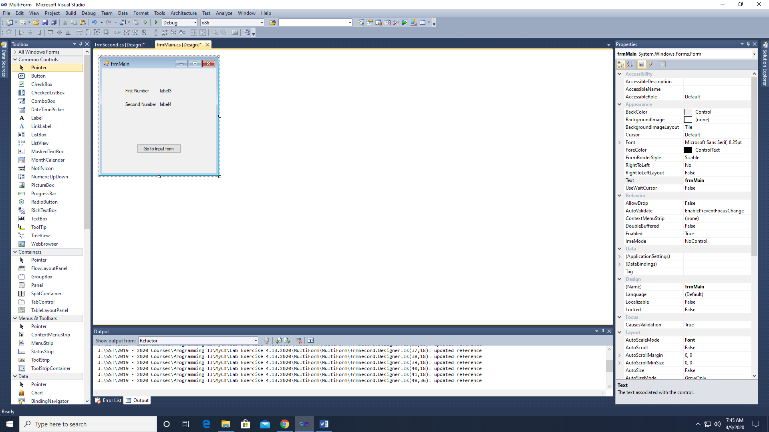

1. Set the following properties

Label1.Text = “First Number”

Label2.Text = “Second Number”

Label3.Name = lblFirst

Label4.Name = lblSecond

Button1.Name = btnNewForm

Button1.Text = “Go to input form”

Form1.Text = “frmMain”

1. Add controls to frmSecond (2 labels, 2 textboxes, and 1 button)

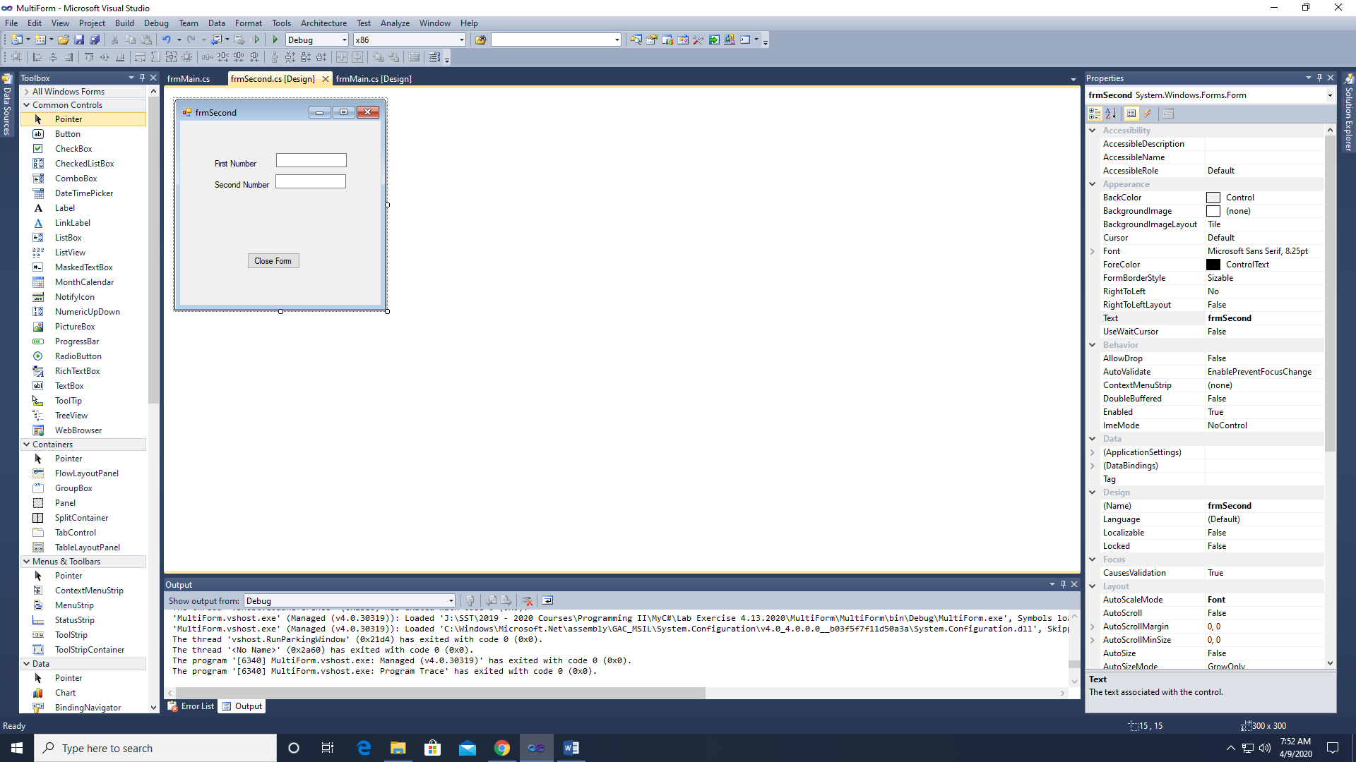

1. Set the following properties

Label1.Text = “First Number”

Label2.Text = “Second Number”

Textbox1.Name = txtFirst

Textbox2.Name = txtSecond

Button1.Name = btnClose

Button1.Text = “Close Form”

1. Add the following event handler to frmMain

private void btnNewForm_Click(object sender, EventArgs e)

{

frmSecond second = new frmSecond();

second.ShowDialog();

}

1. Create a global public static variables for frmMain

public static double number1;

public static double number2;

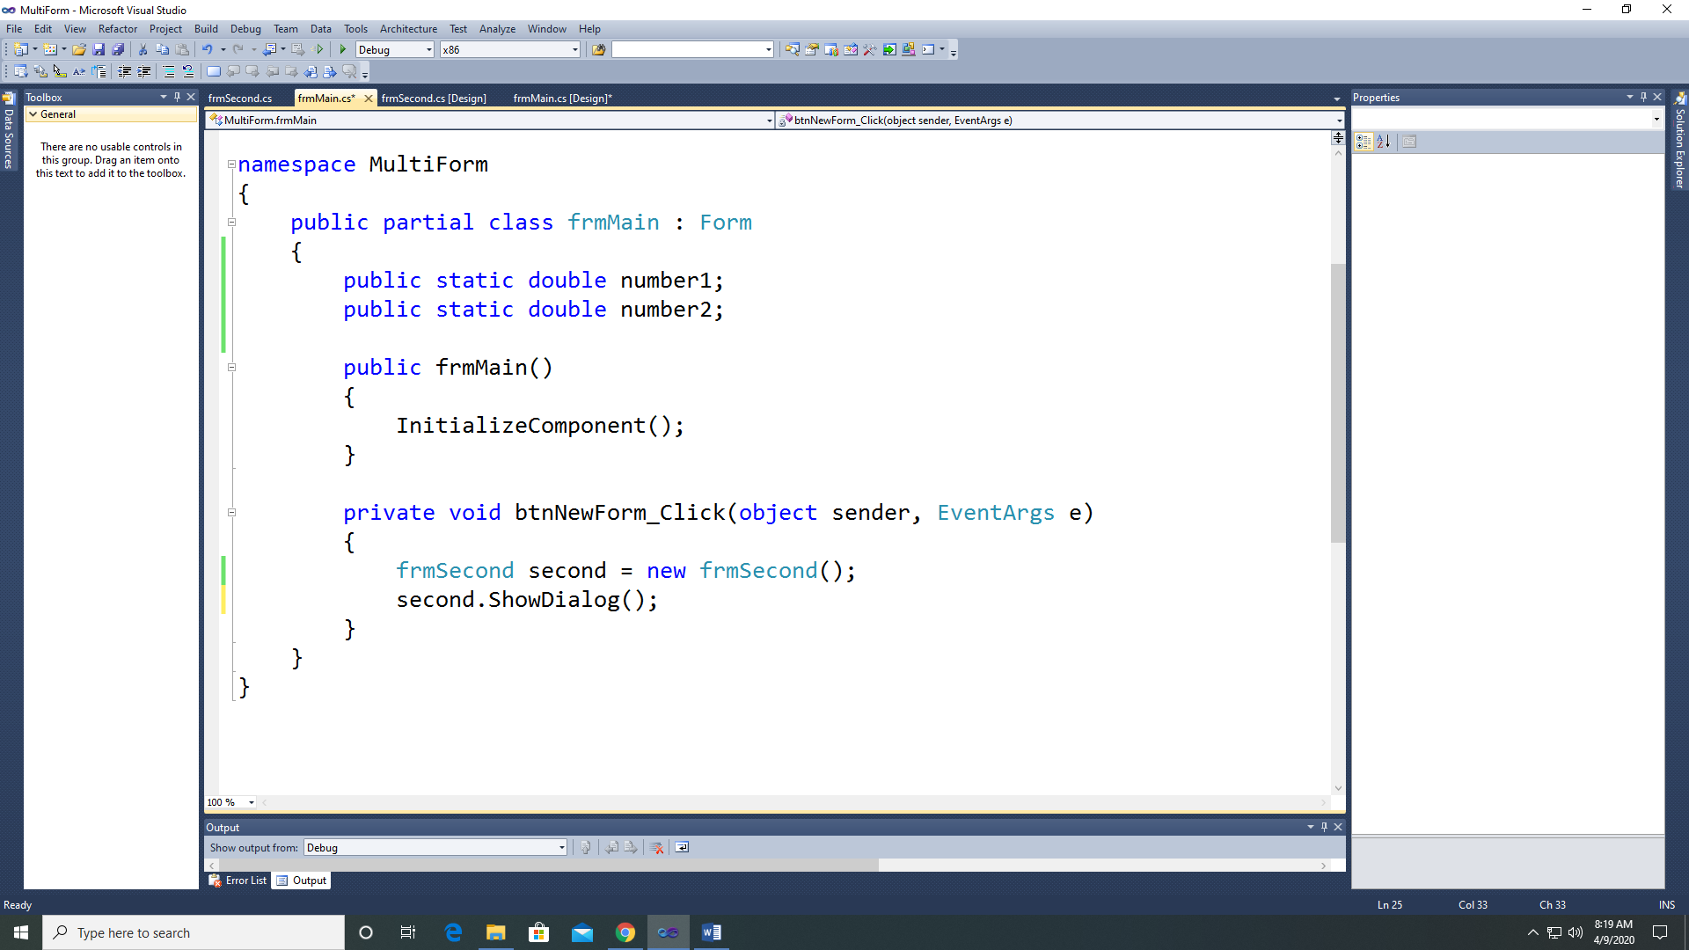

frmMain code

1. Add the following event handler to frmSecond

private void btnClose_Click(object sender, EventArgs e)

{

//Declare variables

double num1, num2;

//Get values from textboxes

num1 = Convert.ToDouble(txtFirst.Text);

num2 = Convert.ToDouble(txtSecond.Text);

//send data back to frmMain

frmMain.number1 = num1;

frmMain.number2 = num2;

//Close the form

this.Close();

}

1. Add the following lines to the btnNewForm_Click event handler.

lblFirst.Text = number1.ToString();

lblSecond.Text = number2.ToString();

1. Now test your program.

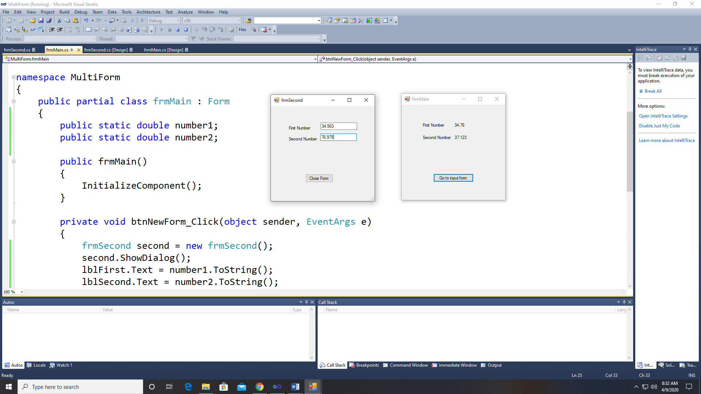 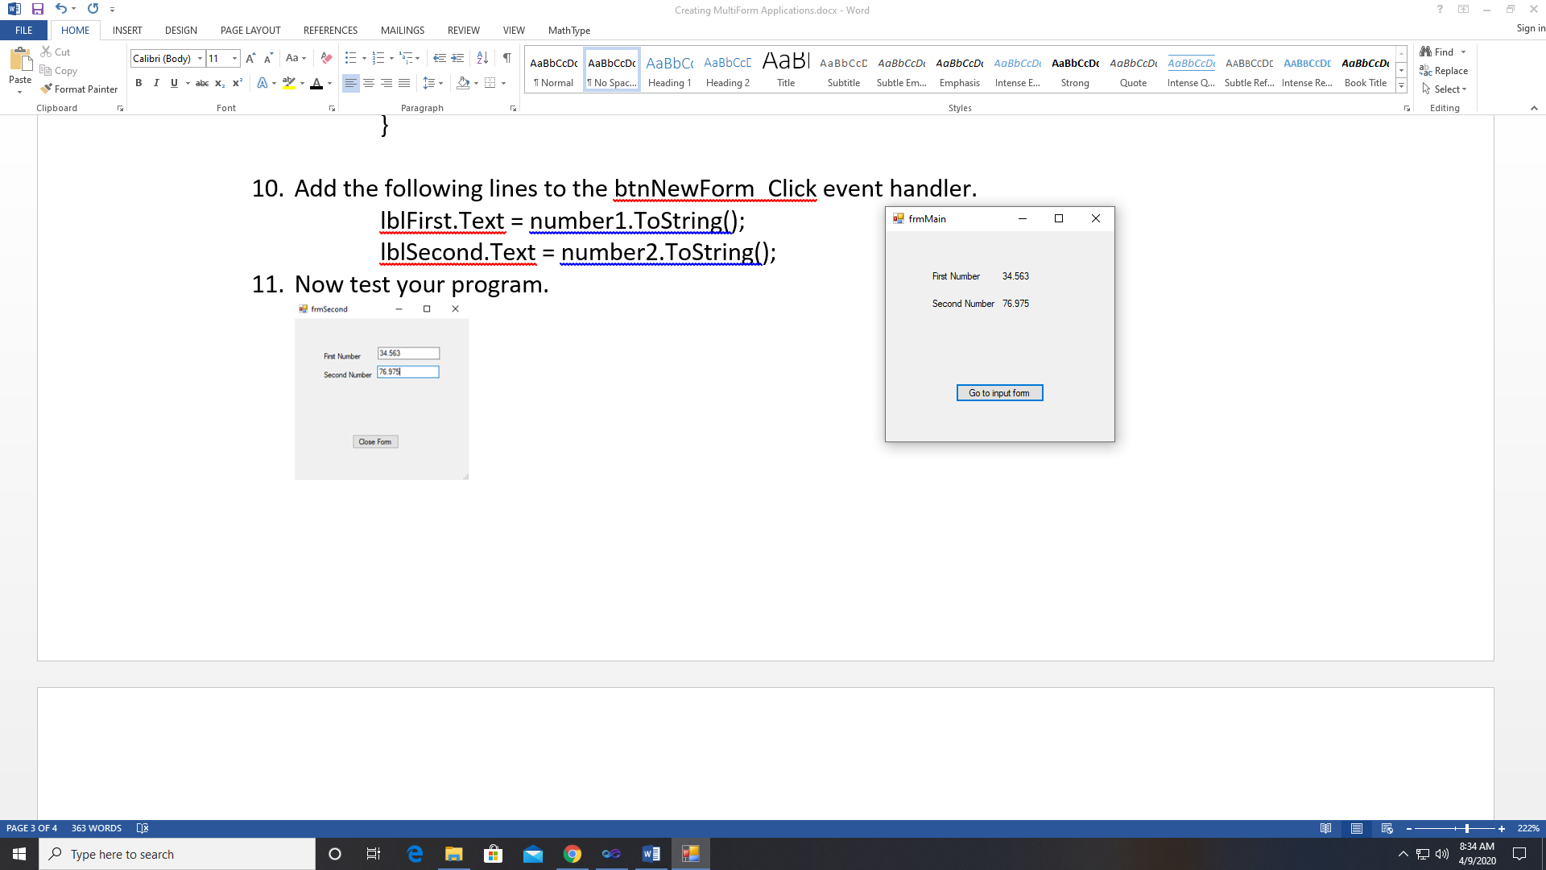

1. Opening a multiform project. If you look at the Solution Explorer, you should see this.

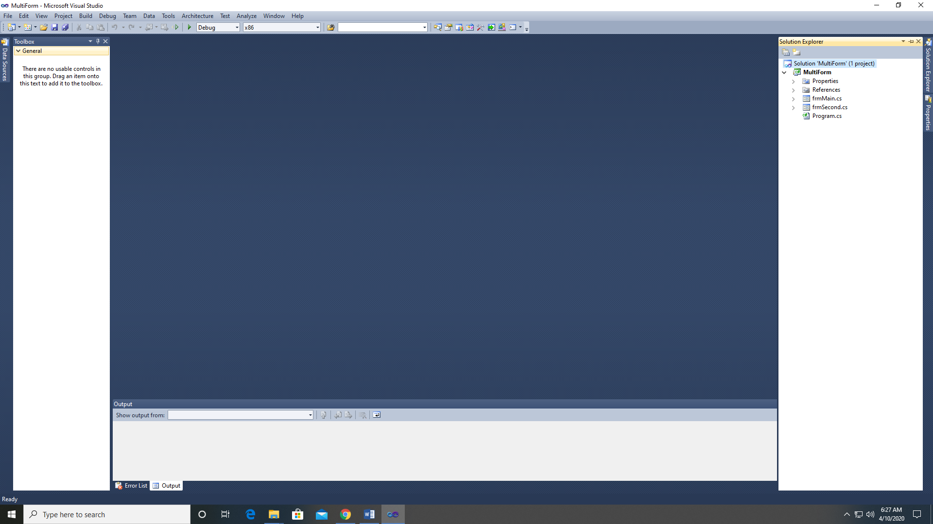

1. To open a form (such as frmMain), just double-click on frmMain.cs or frmSecond.cs. This will open the form in Design mode.

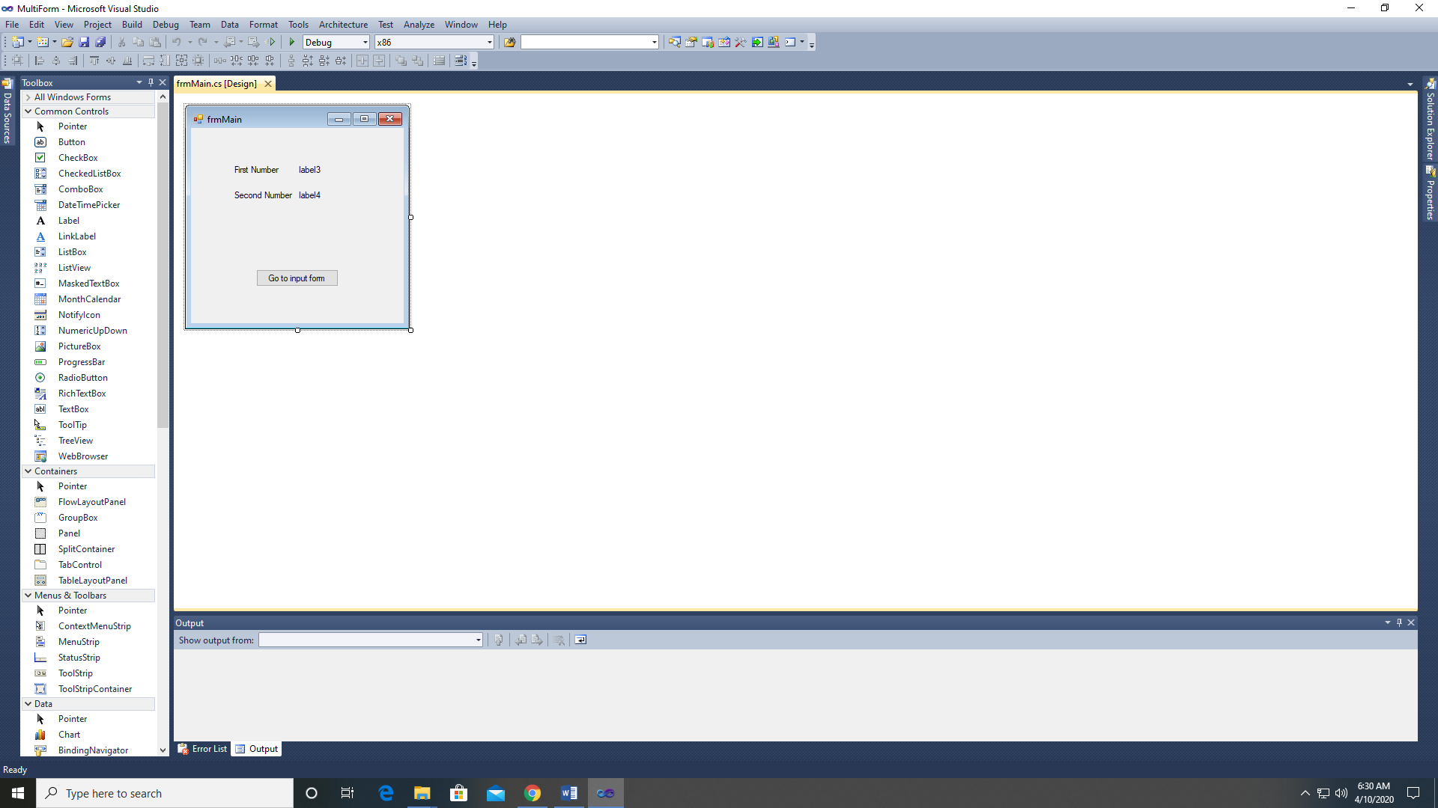

1. To get to the code, just hit F7.

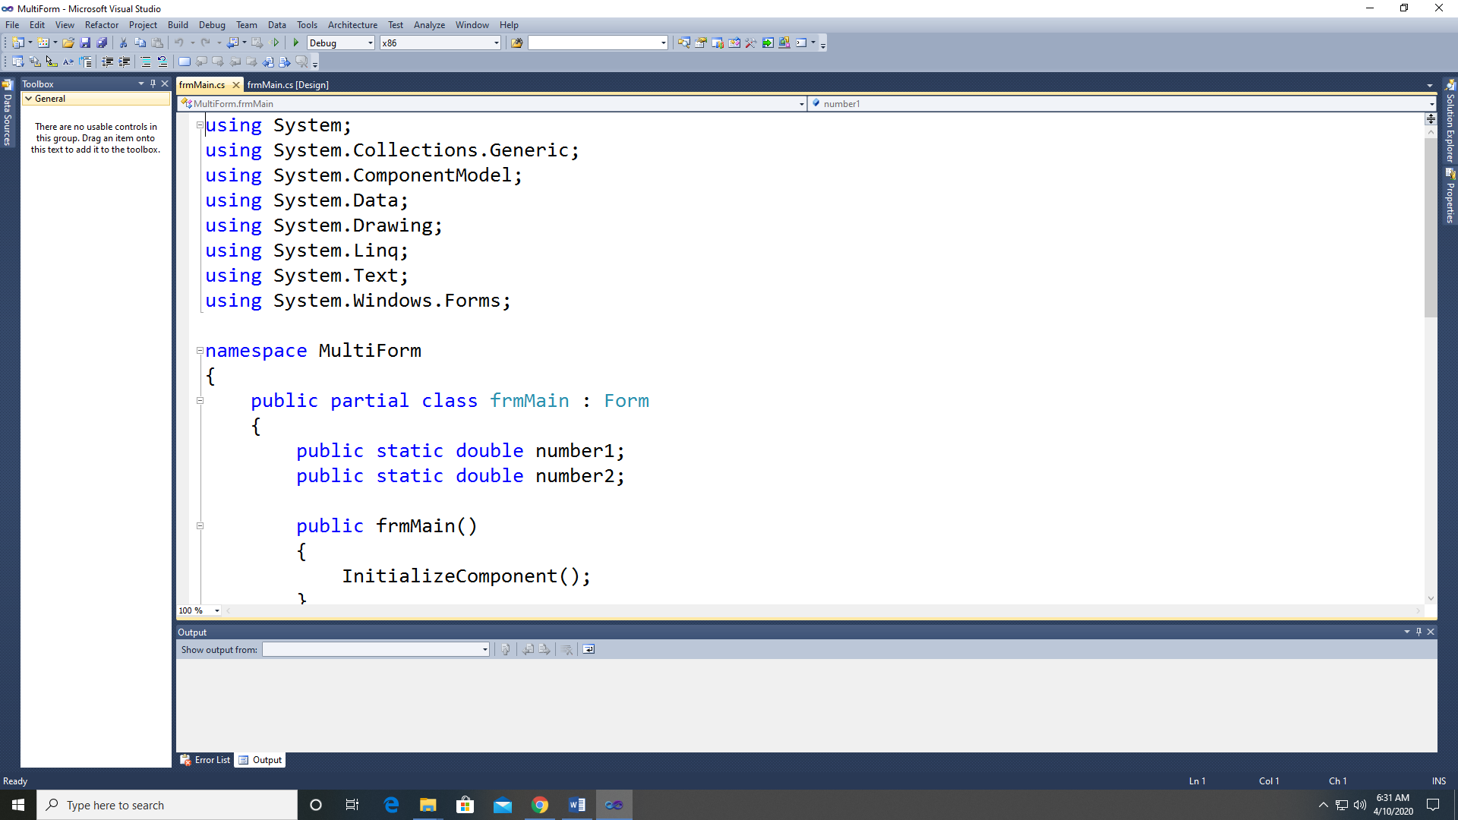

1. With everything open, your screen should look like this.

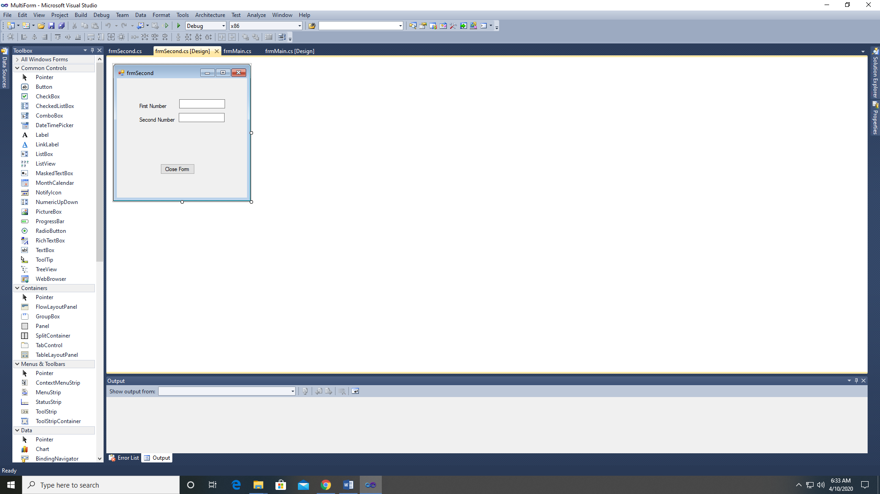

1. Notice the 4 tabs across the top; frmSecond.cs, frmSecond.cs(Design), frmMain.cs, and frmMain.cs(Design).